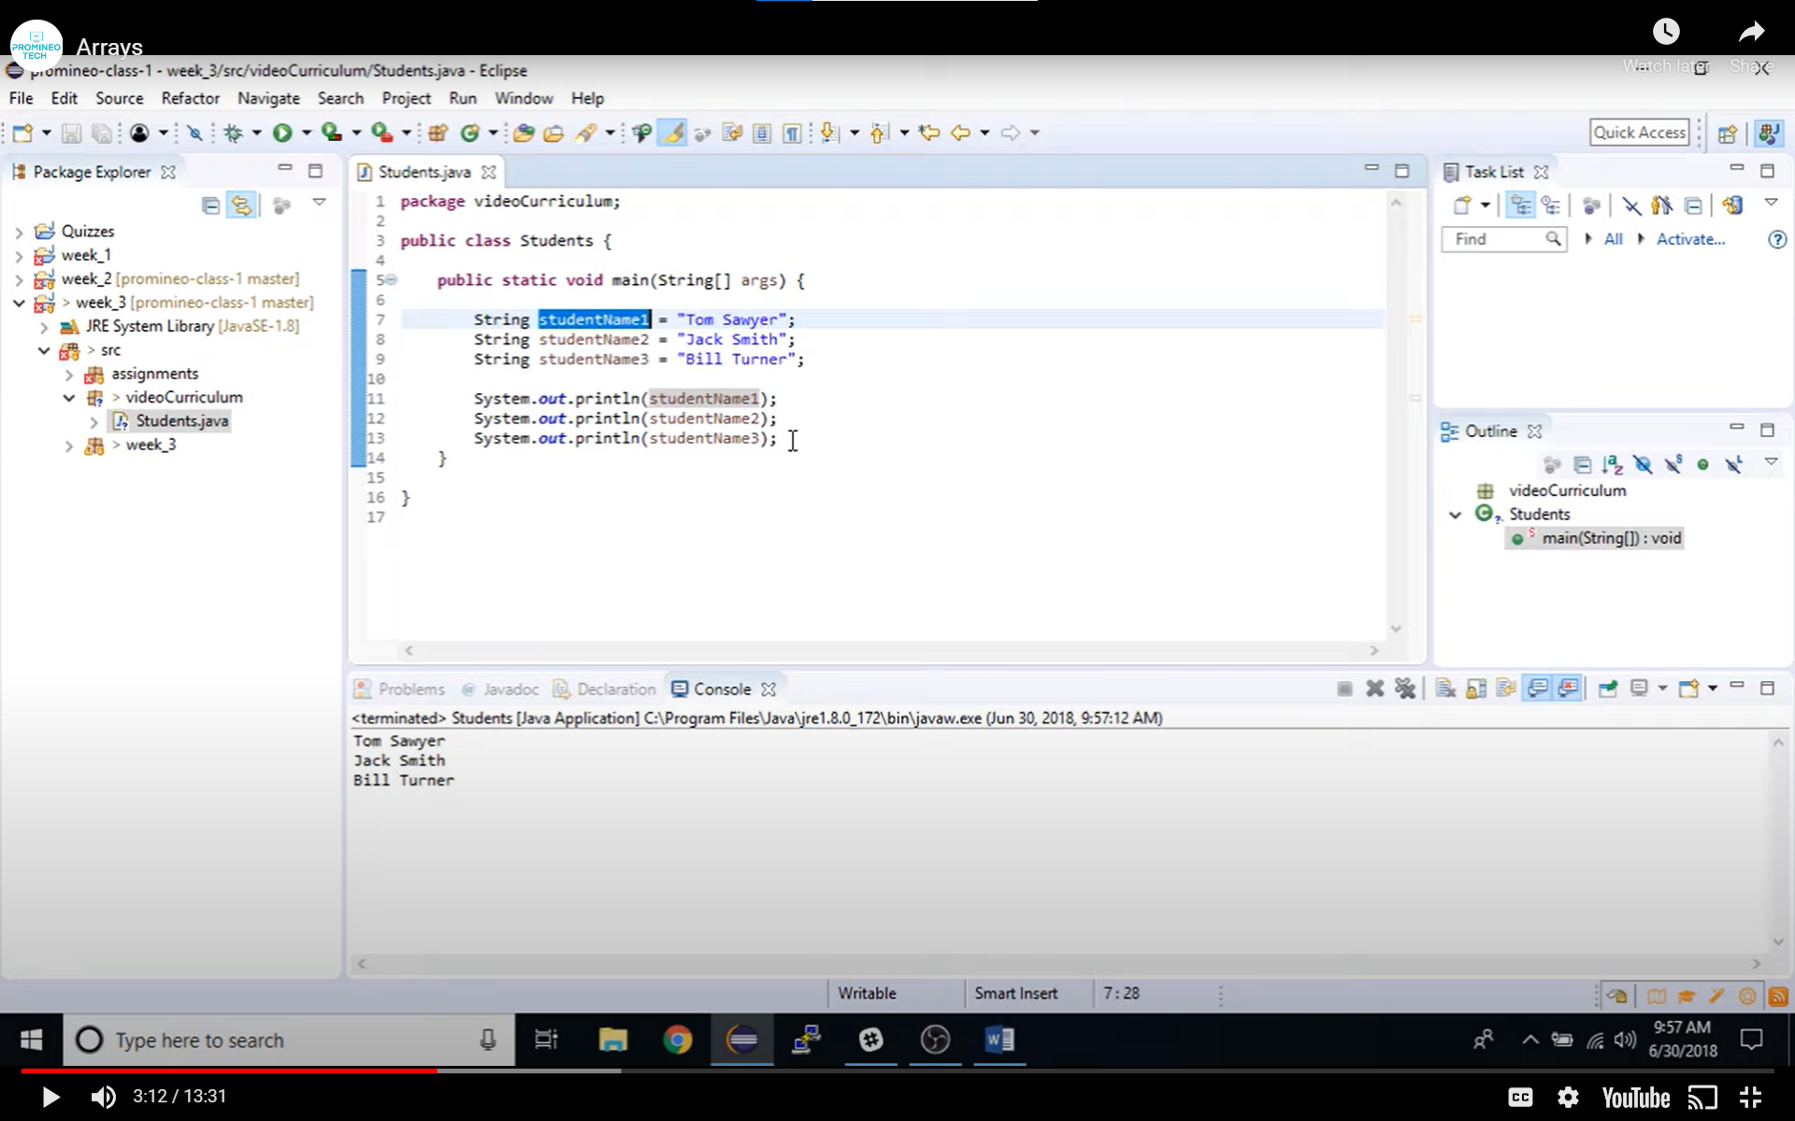

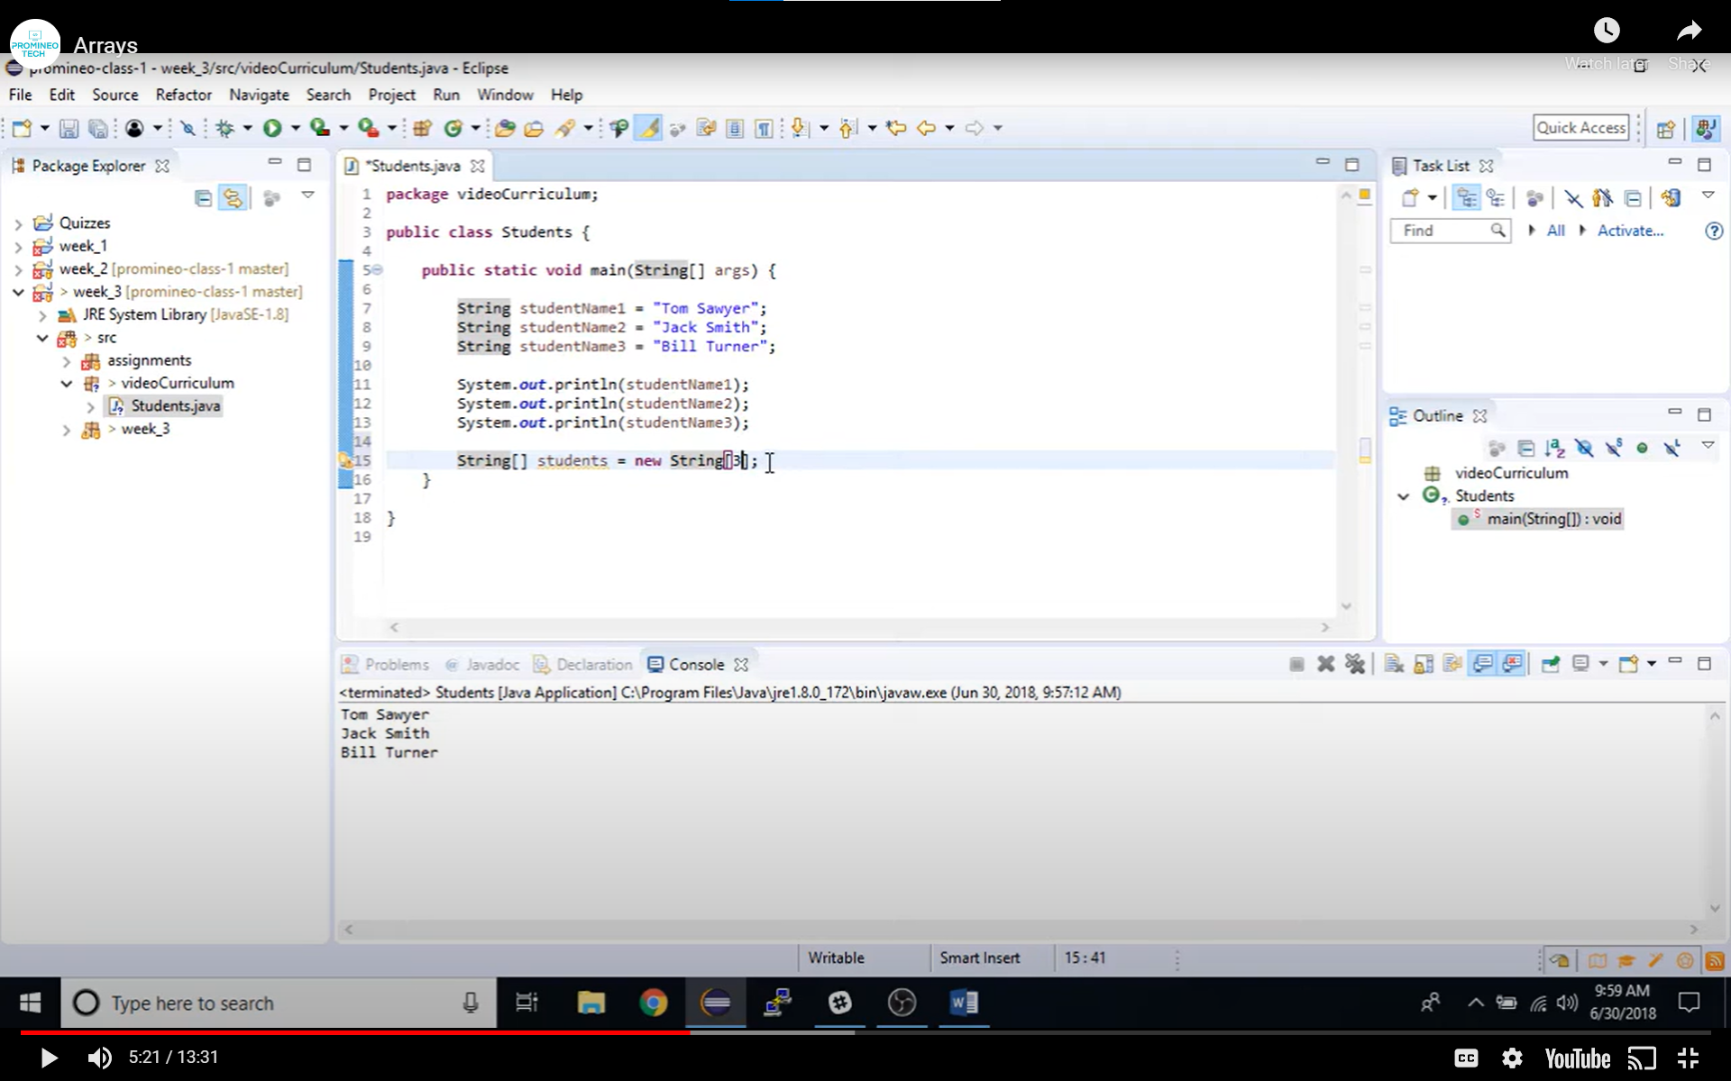

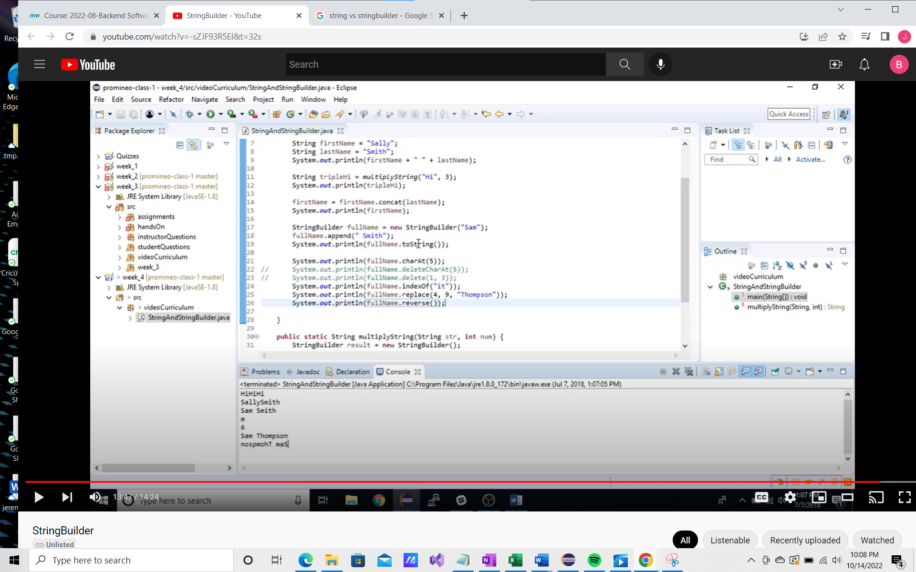

The above is an array verified by [ ] start by identifying a data type. Array holds multiple values, whereas a variable holds only 1

Consist f variable type, the [] square brackets, assignment operator = new and then add variable type back. The example above variable type string [], assignment operator student = new variable[“indicates how many elements ]. In the example above elements equals 3 and will be assigned starting at zero.

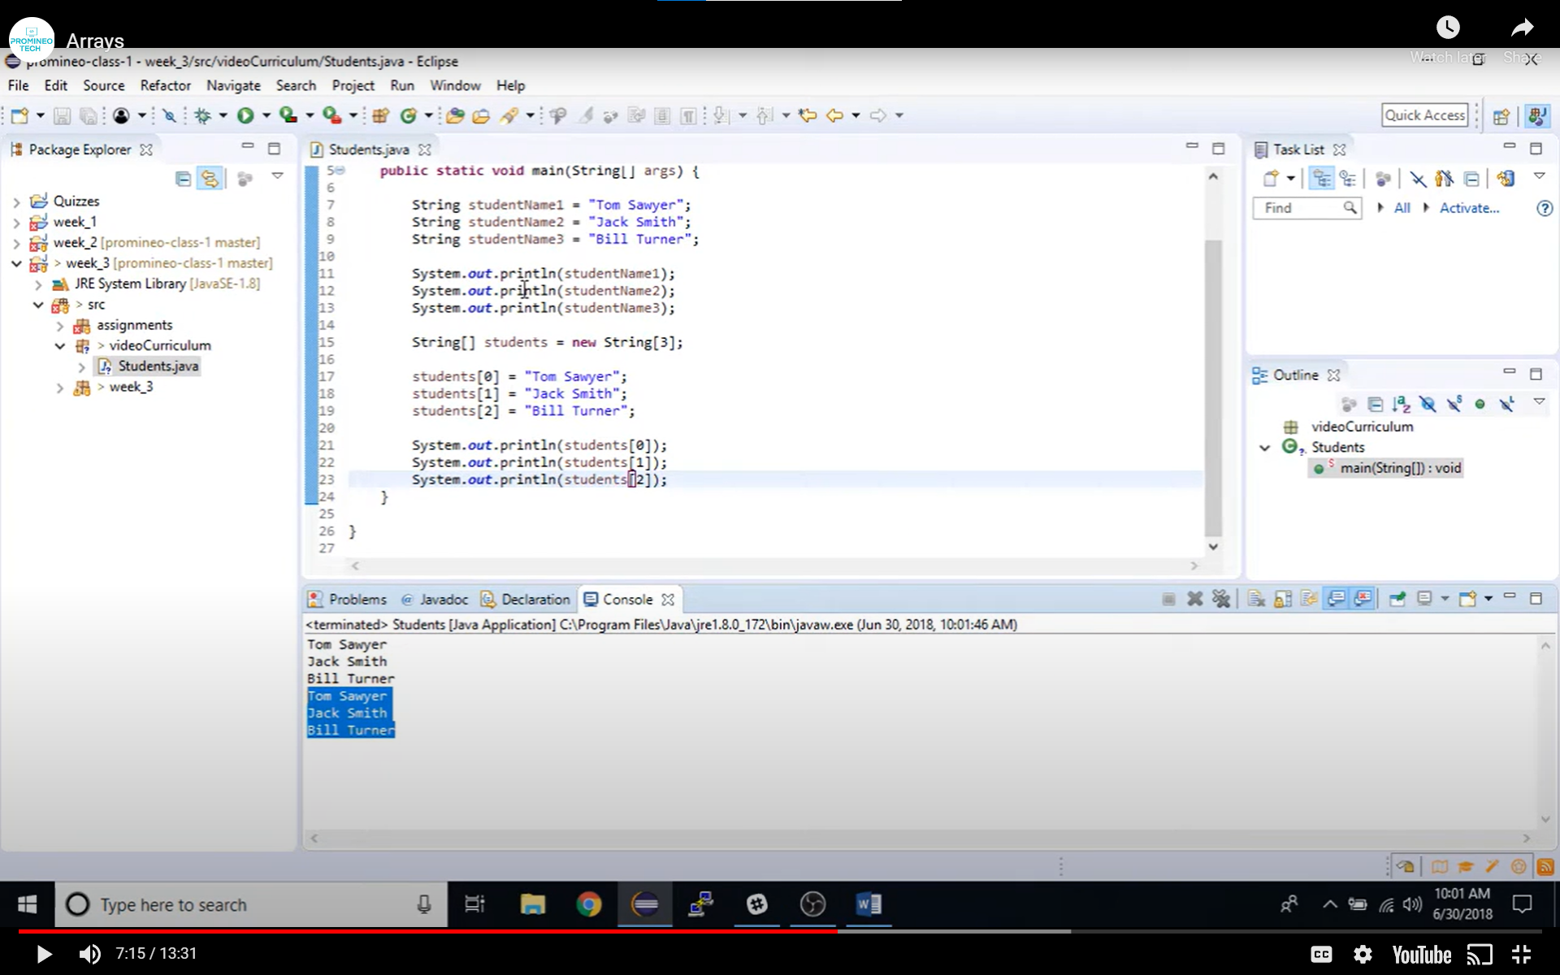

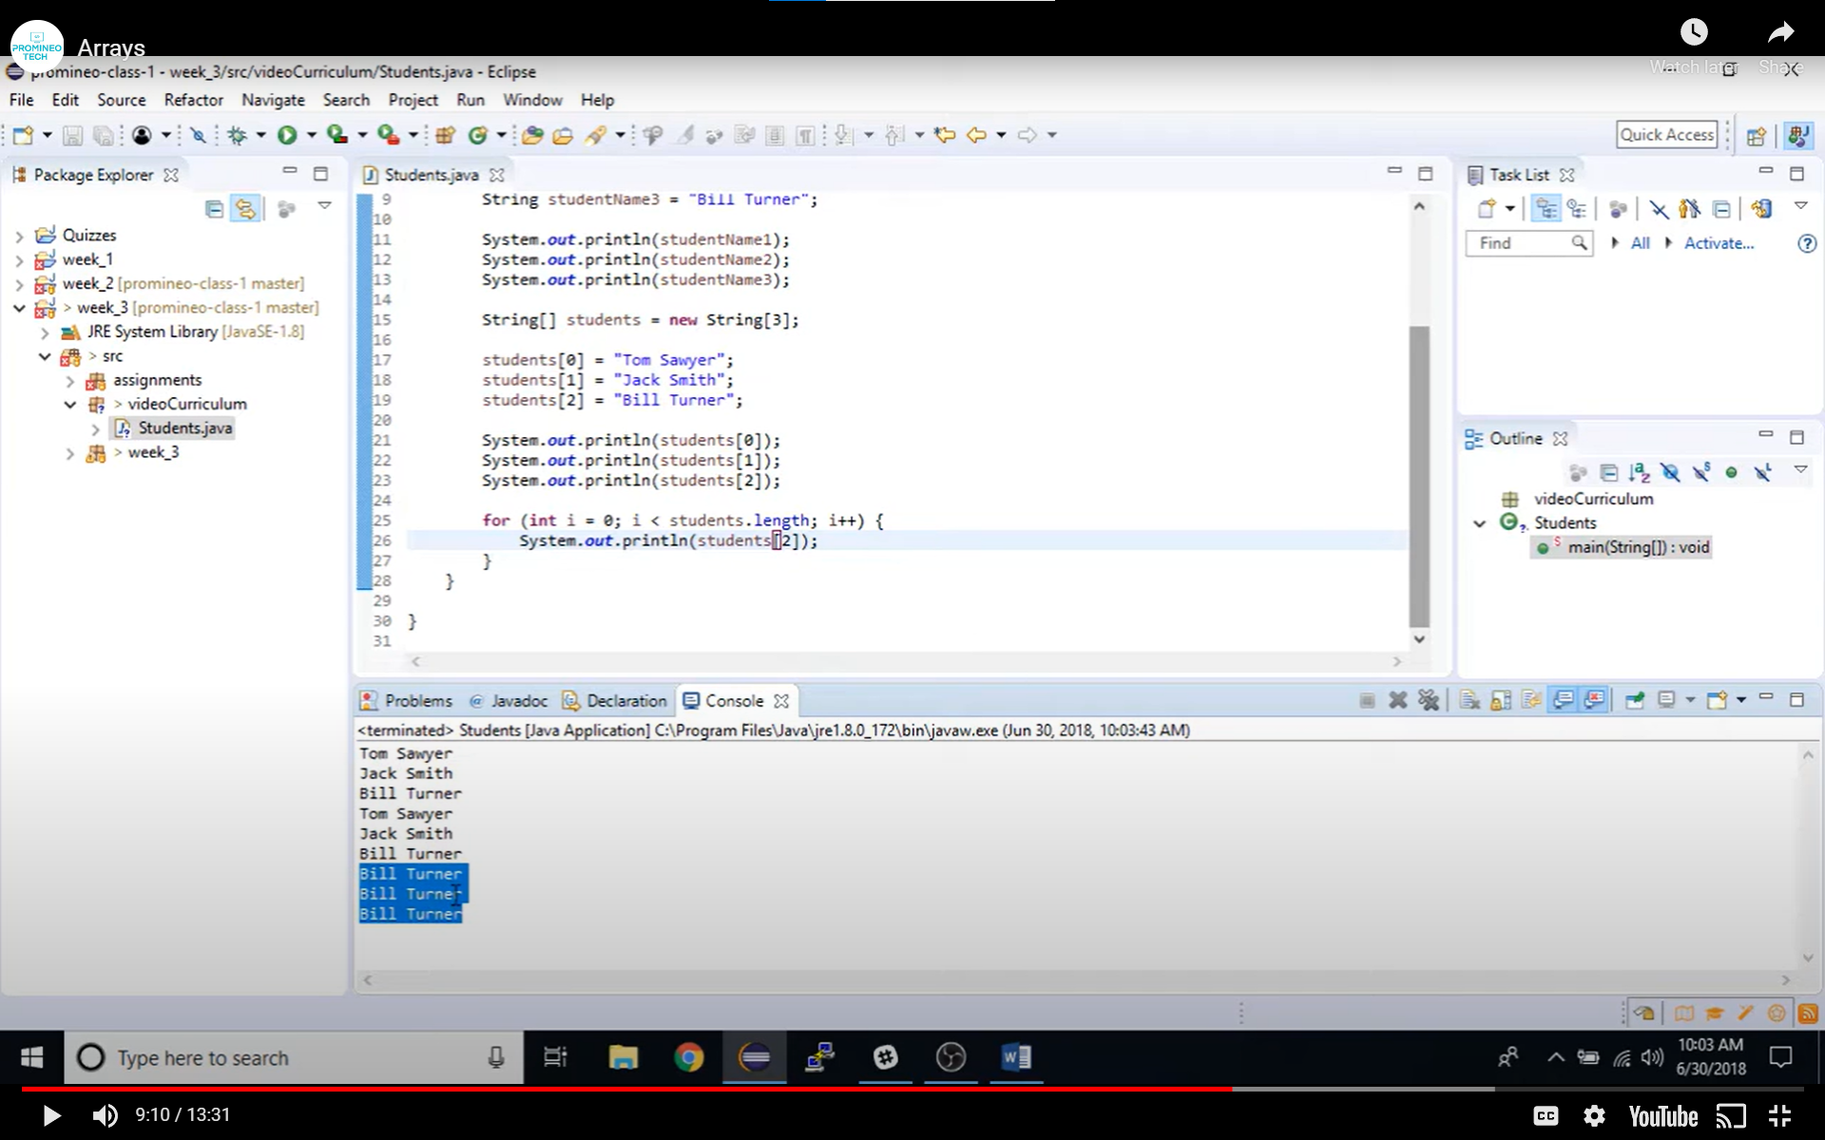

Using a for loop

Define array in this case string [] students = new String[3]

Identify each student in the array students [0] = “Tom Sawyer”;

For loop

for (int i = 0; I < student.length; i++) {

system.out.println(students[ i if you want to print all or can type an individual number to generate the name for student 0, 1, or 2]; note if you select 1,2, or three in this example the code associated with that lin will print 3 times.

Or you can use an enhanced “For LOOP”

//amigoscode

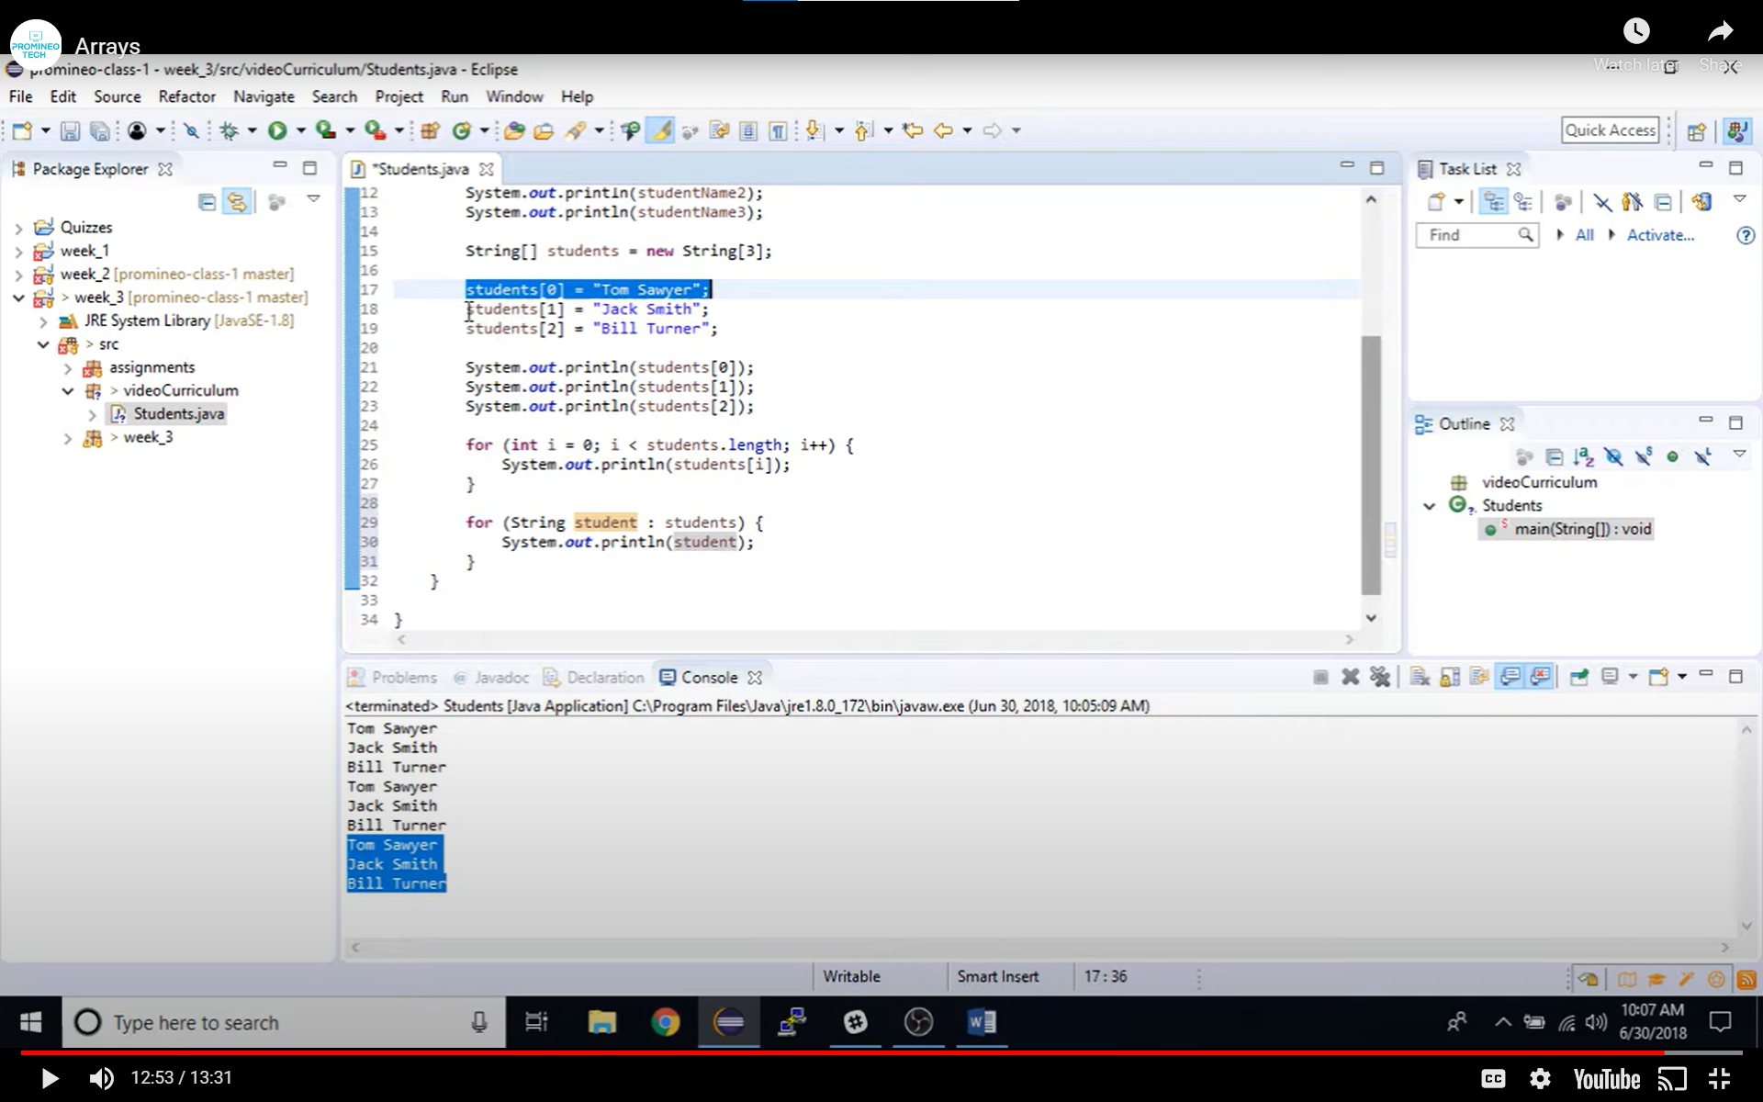

Your variable name in the for loop can be anything in the above example we will read as for each student in “students which is the variable names assigned in the array”. We can now sysout student, and will return all values in the array

More Arrays

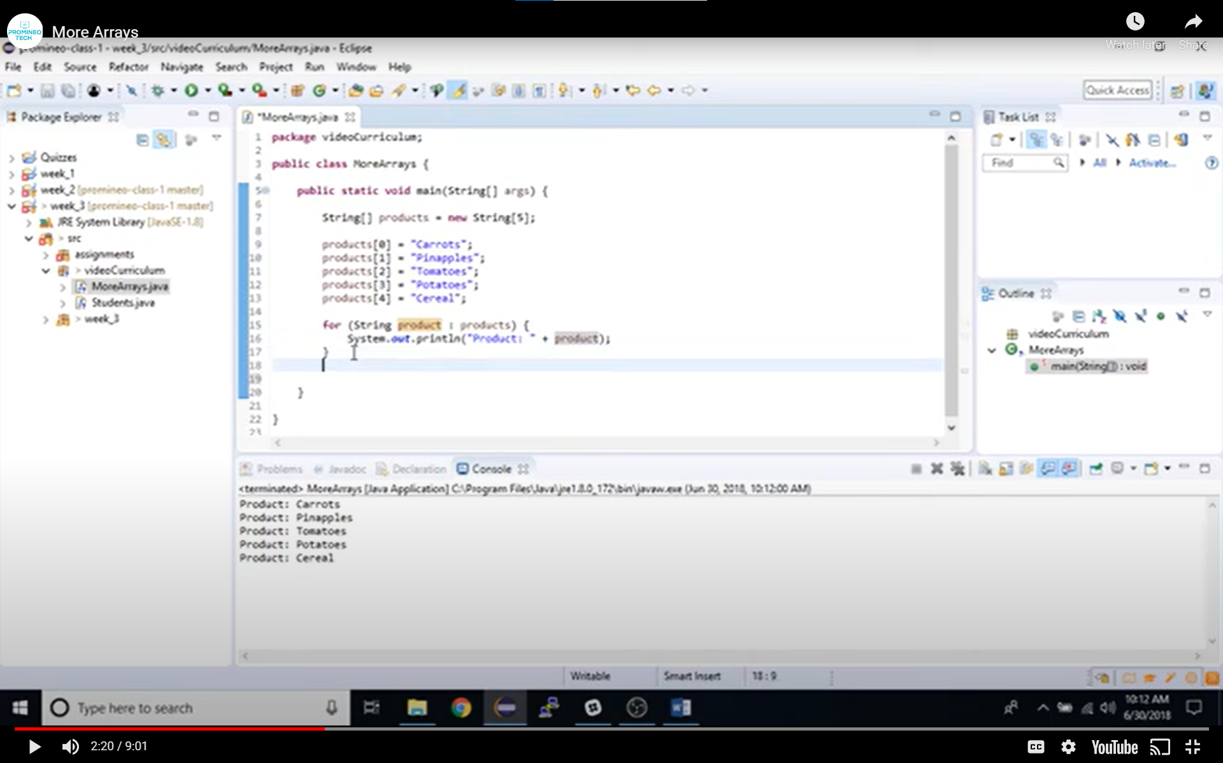

Multiples of 3 or 5 beginning with 1 or 0

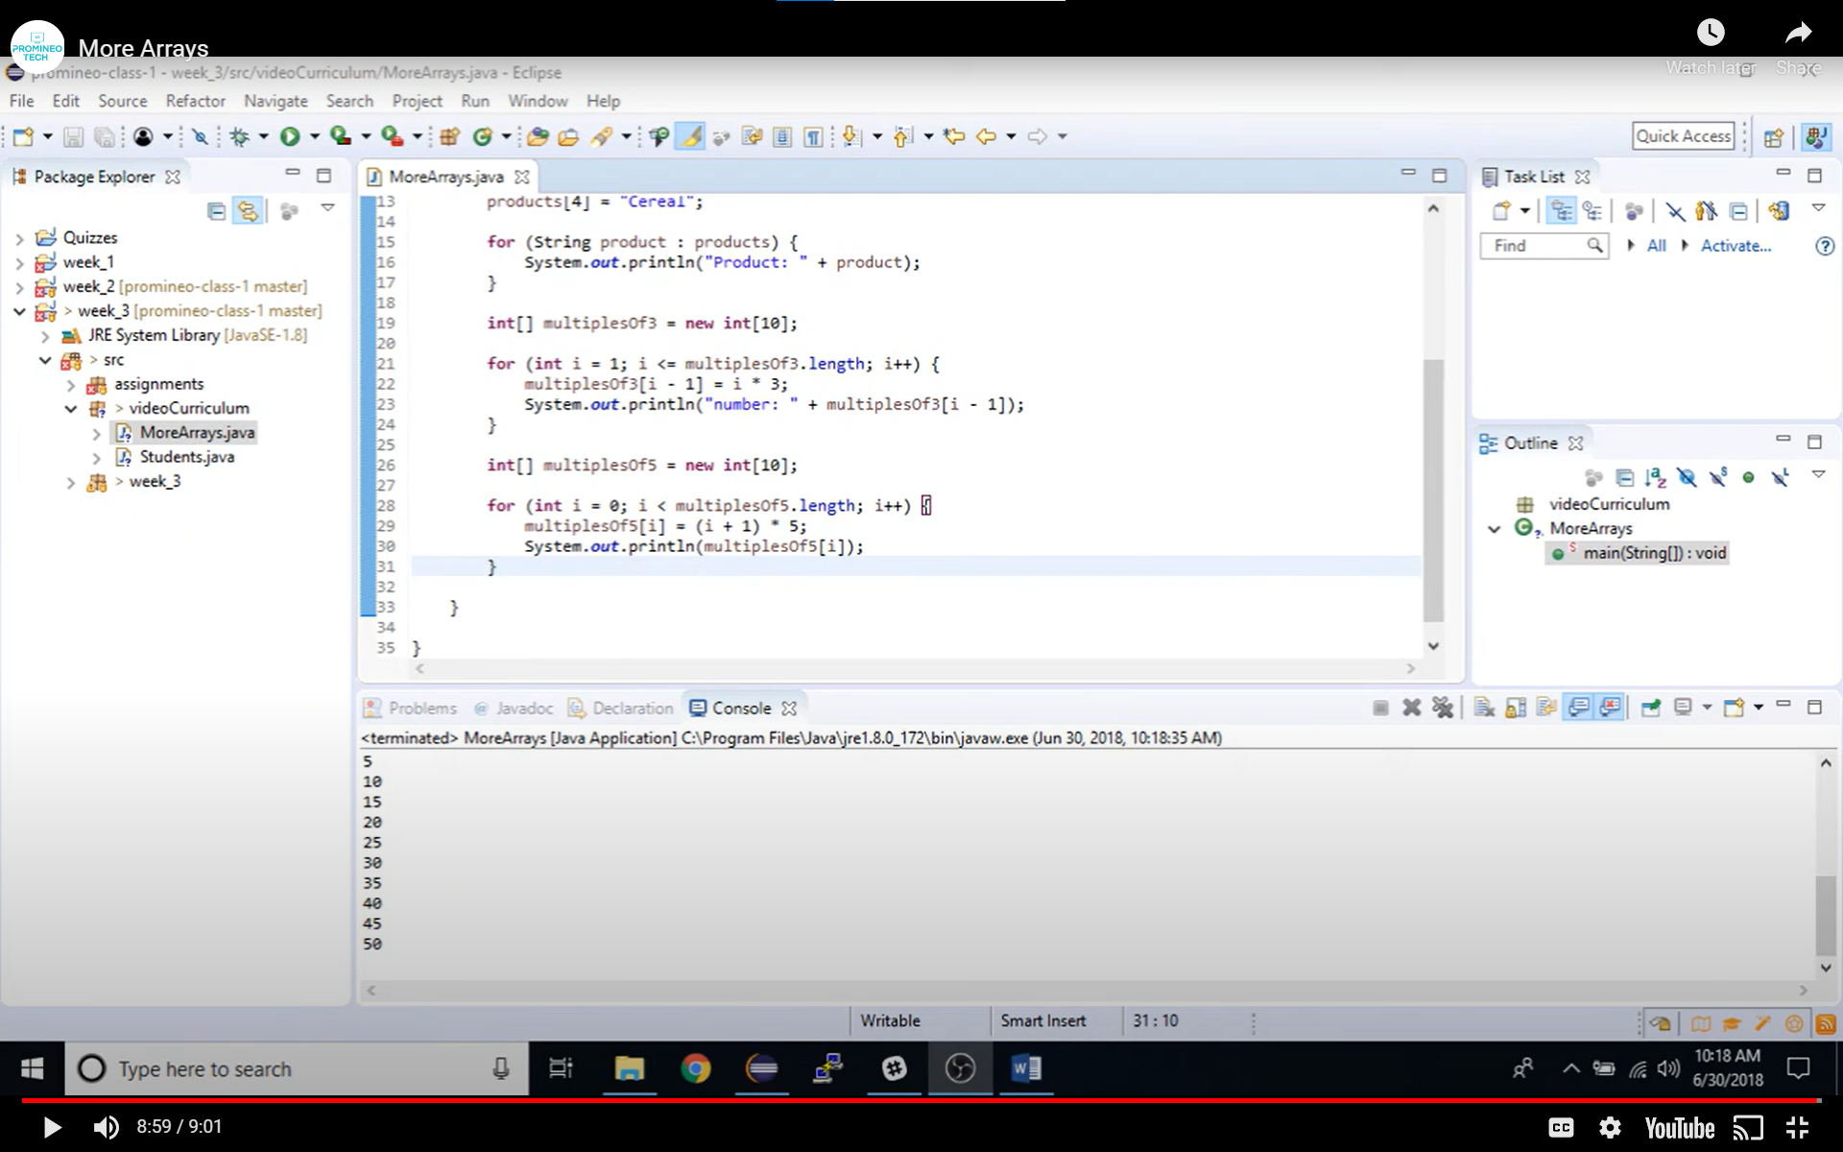

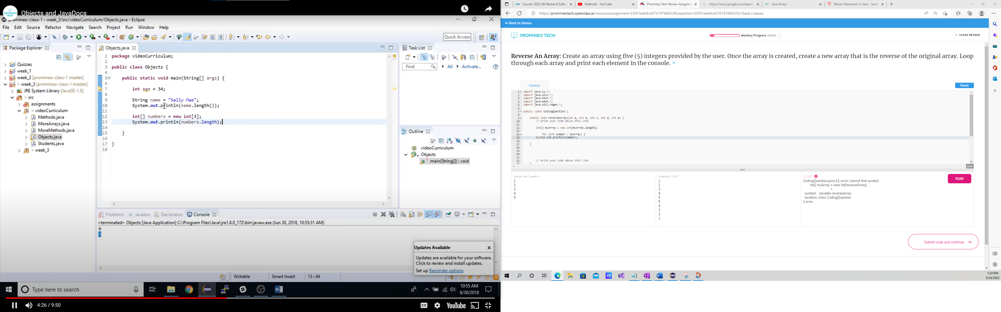

**Create & Return An Array of Characters**: In the method wordToArray take the value of userWord and turn it into an array of characters from each letter in word. Call your new array charArray and return that variable in the method wordToArray.

‘

